**SVKM’s NARSEE MONJEE INSTITUTE OF MANAGEMENT STUDIES**

# MUKESH PATEL SCHOOL OF TECHNOLOGY MANAGEMENT AND

# ENGINEERING

# A REPORT ON

# Microsoft Analysis

BY:

M.Pratyush

SAP ID:70022100434

COURSE: B(TECH.) COMPUTER ENGINEERING

Under the supervision of

**Prof. Suraj Patil**

(Asst. Professor, CS Department, MPSTME)

## Table of Contents

|  |  |
| --- | --- |
| Contents | Page  No |
| 1.1 Problem Statement | 3 |
| 1.2 Background of the Project Topic | 3 |
| 1. 1.3 Dataset Description | 3 |
| 1. 1.4 Software Tool Used | 3 |
| 1.5 Business Scenario | 3 |
| 1.6 Screenshots of Source code/Output | 4-11 |
| 1.7 Conclusions | 12 |
| 1.8 References | 12 |

**Problem Statement**

To transform, clean, summarize, extract, explore and visulaize the imdb data set on top 1000 movies from the year(1980- 2015). These above mentioned process are done using runtime , ratings and meta score columns of imdb movie database.

Data Cleaning and Transformation

Summary And Head operation on Dataset

Data Extraction

Data filter

Data Exploration and Visualization

**Background of the Project Topic**

Microsoft Analysis of their stocks

**Dataset Description**

Data:

* Date: Date of opening & Closing of stock.
* Open: Opening price of the stock.
* High: Highest price the stock has reached that day.
* Low: Lowest price the stock has reached that day.
* Close: Closing price of the stock.
* Adj.Close: Modified closing price based on corporate actions
* Volume: Amount of stocks sold in a day

**Software Tool Used:**

R studios

**Business Scenario:**

To transform, clean, summarize, extract, explore and visulaize the imdb data set on top 1000 movies from the year(1980- 2015). These above mentioned process are done using runtime , ratings and meta score columns of imdb movie database.

Data Cleaning and Transformation

Summary And Head operation on Dataset

Data Extraction

Data filter

Data Exploration and Visualization

**Screenshots of Source code/Output**

Source Code

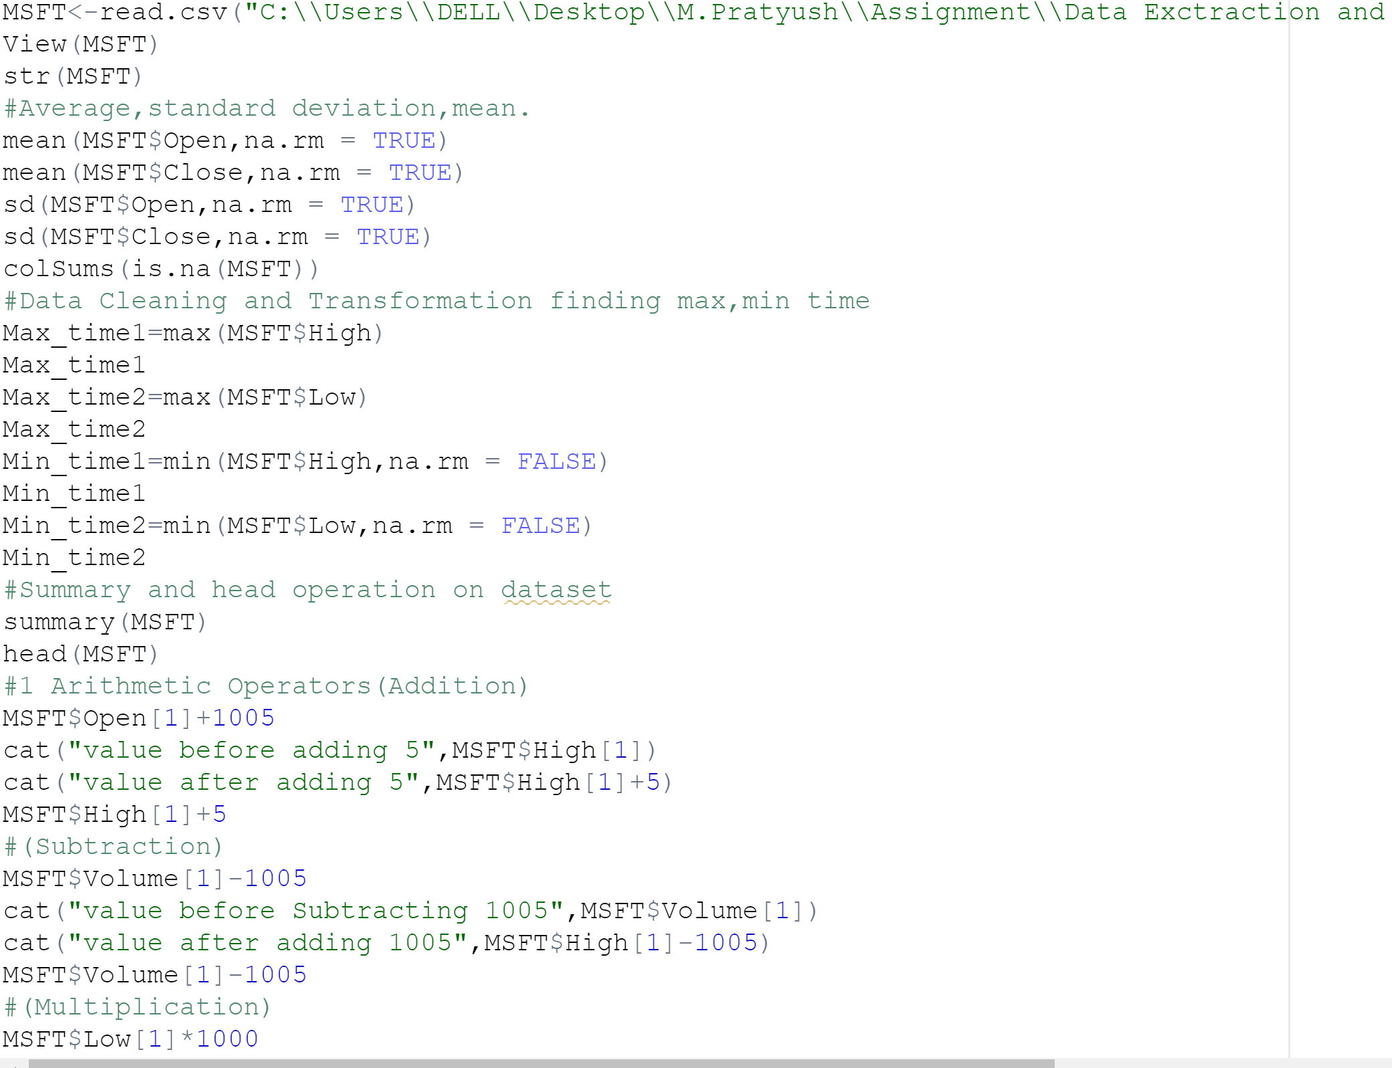

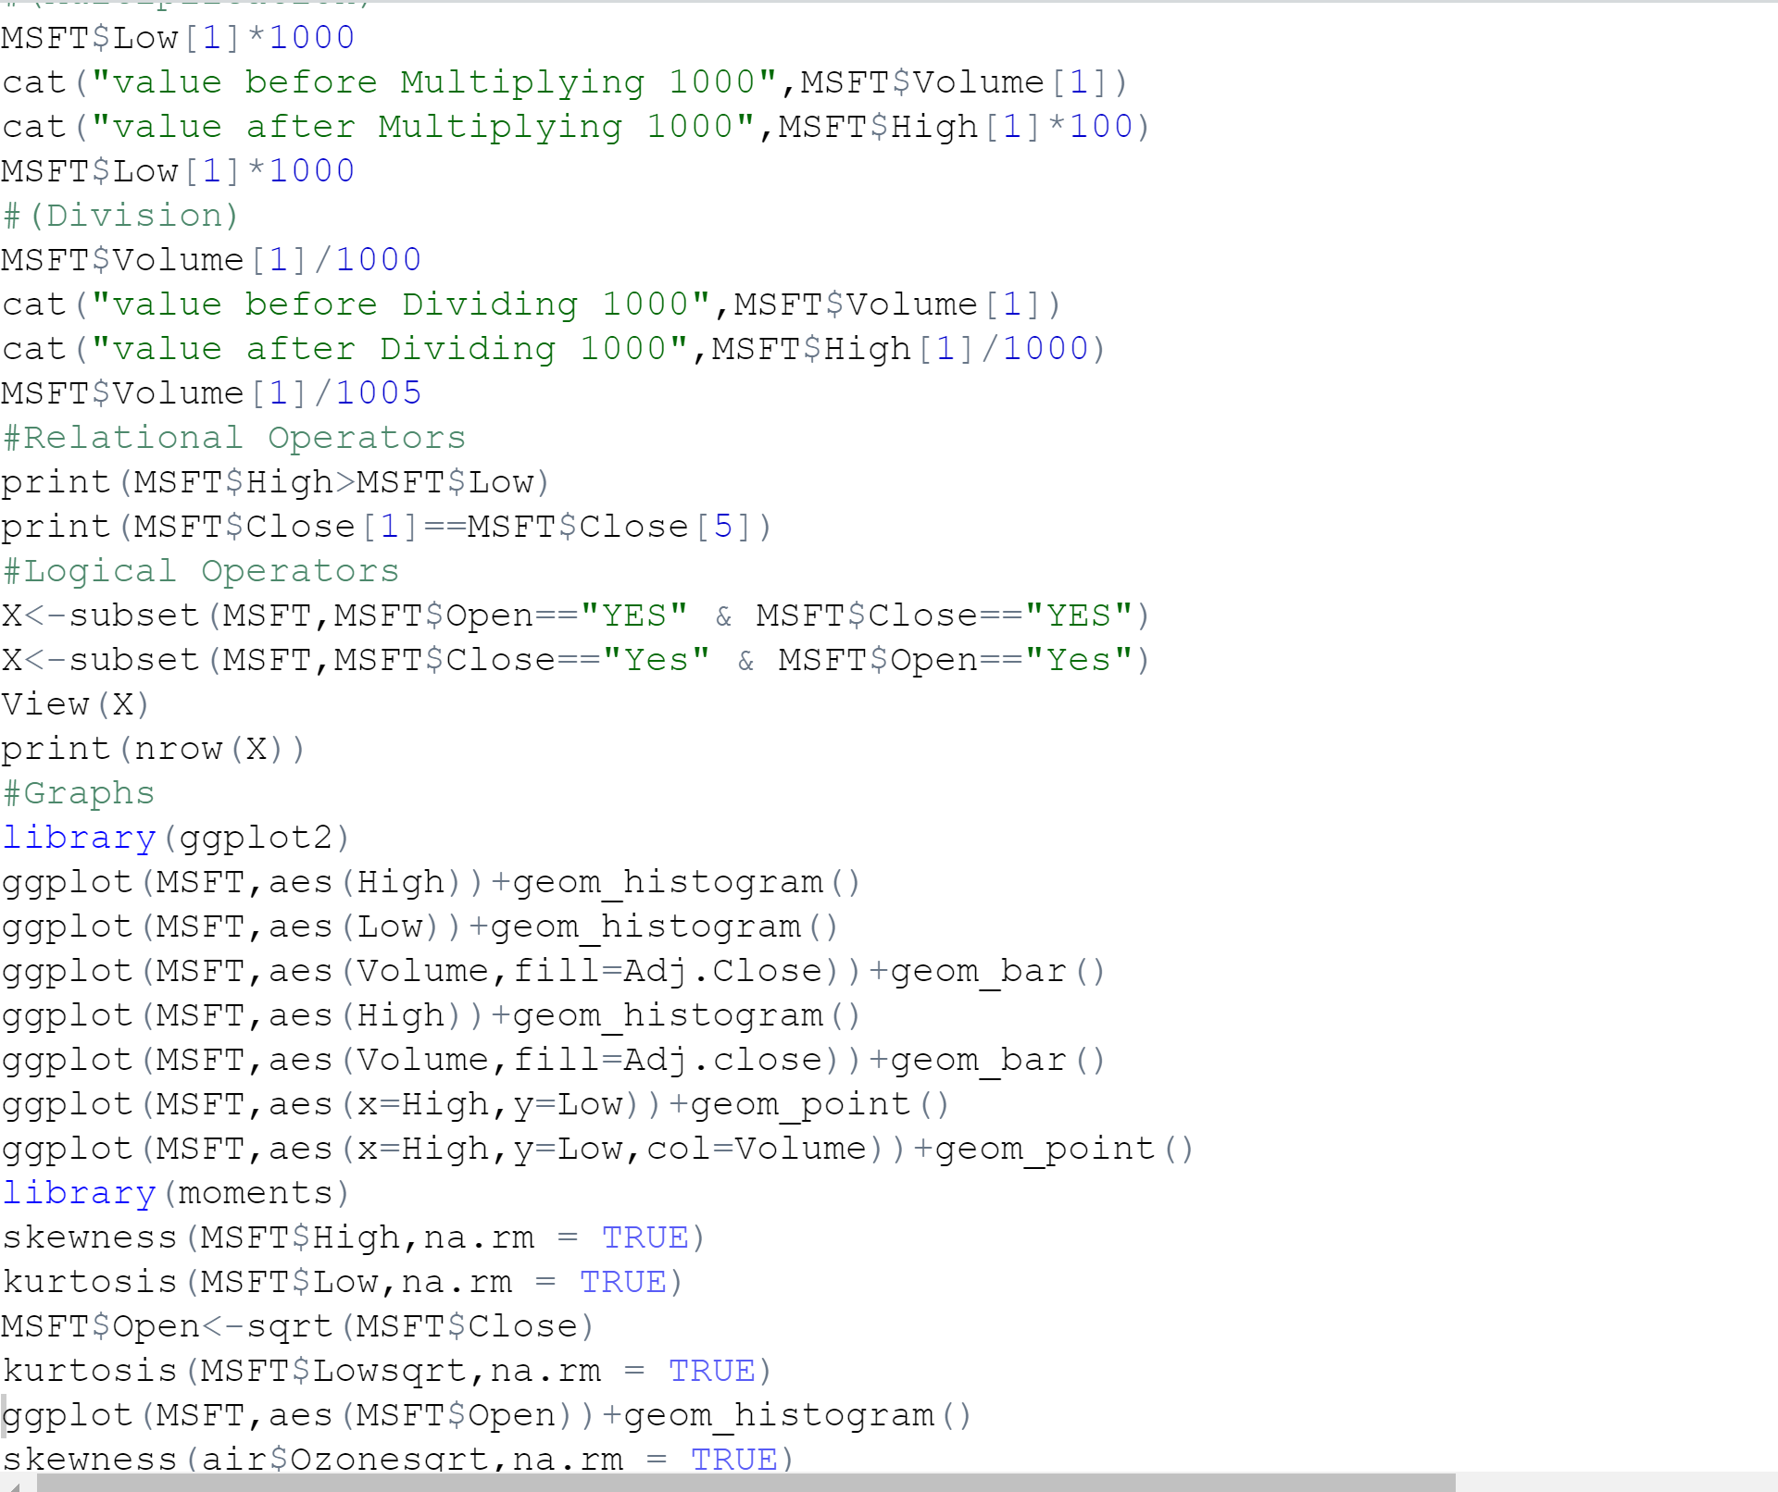

Output

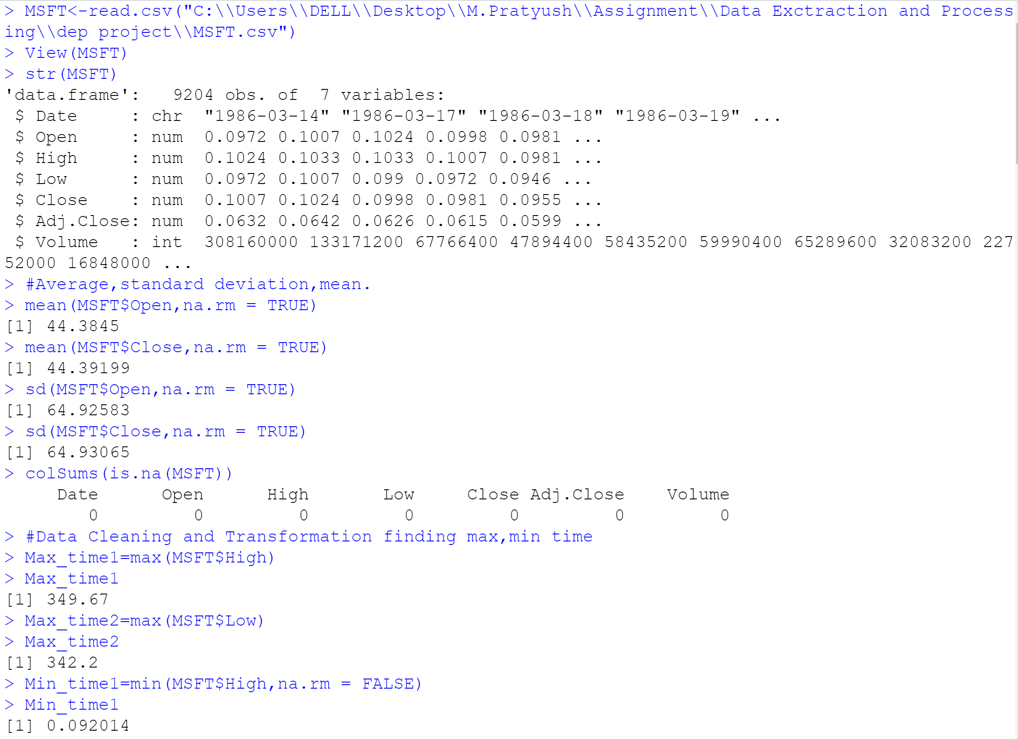

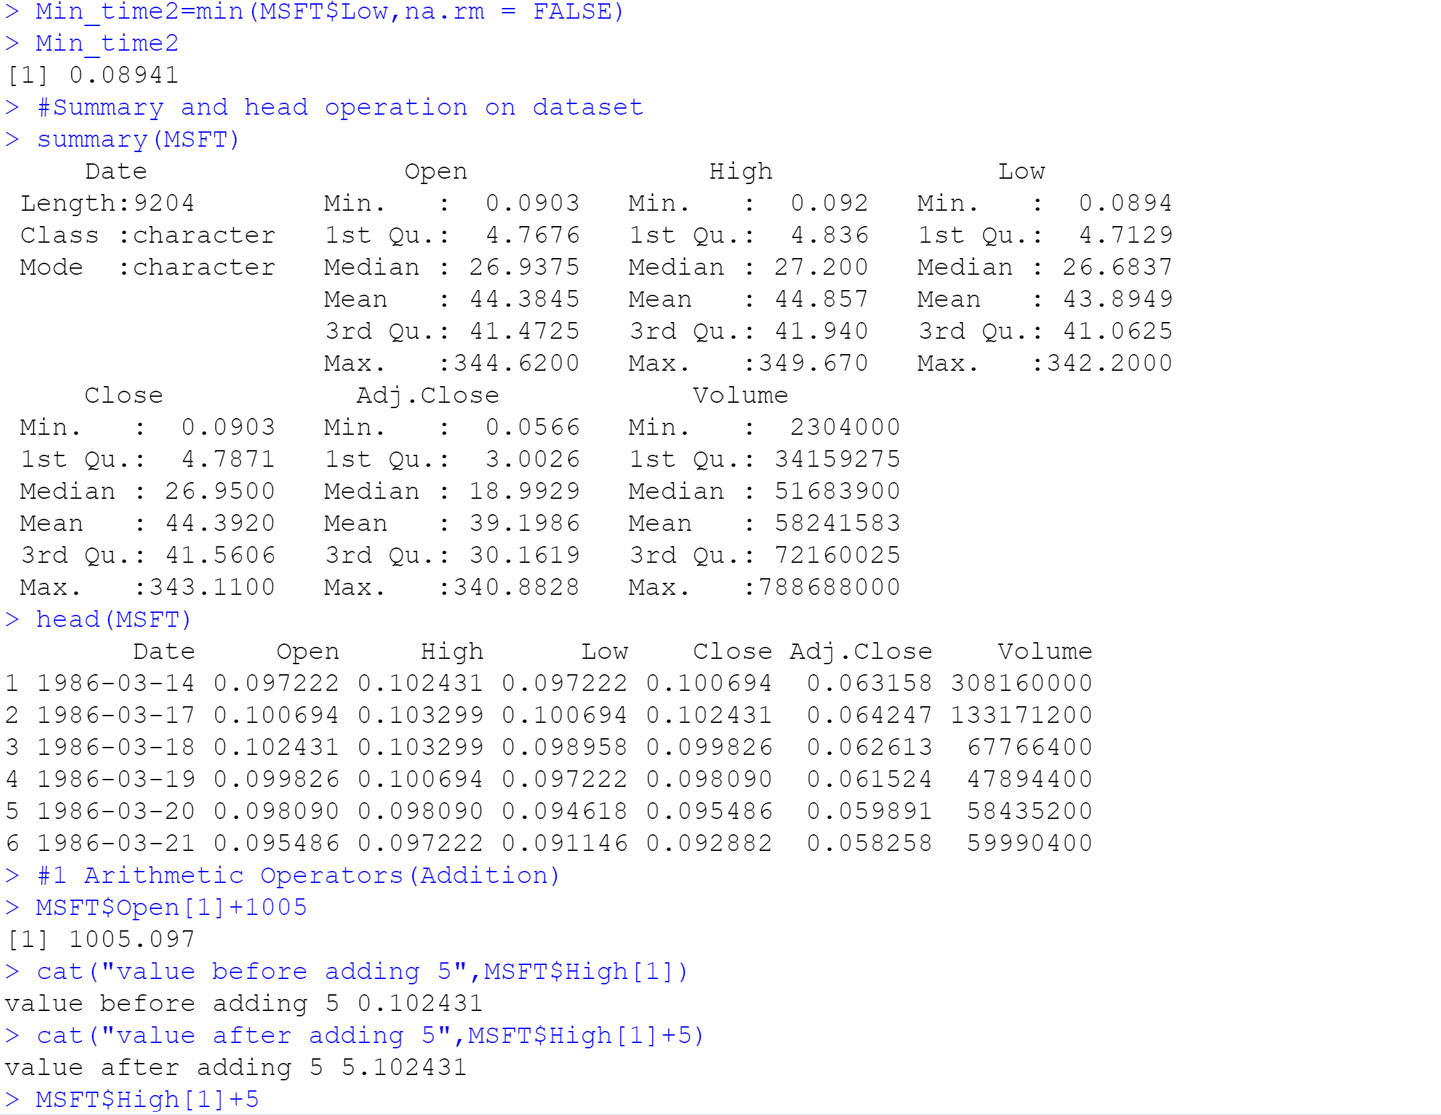

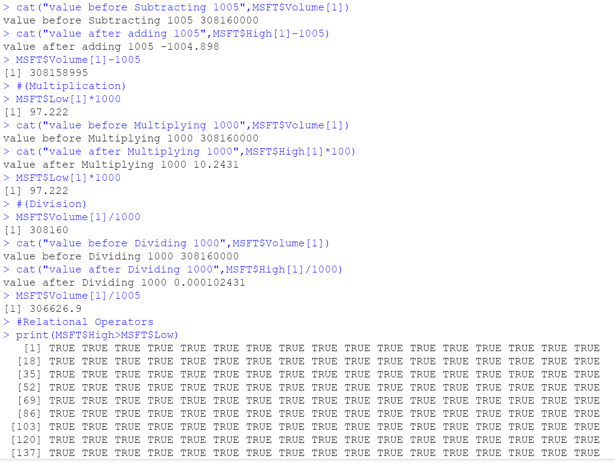

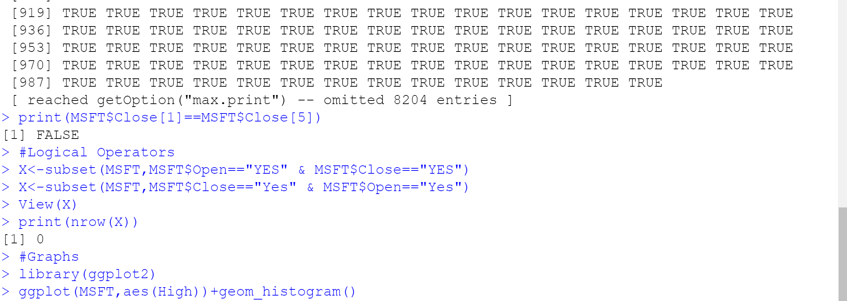

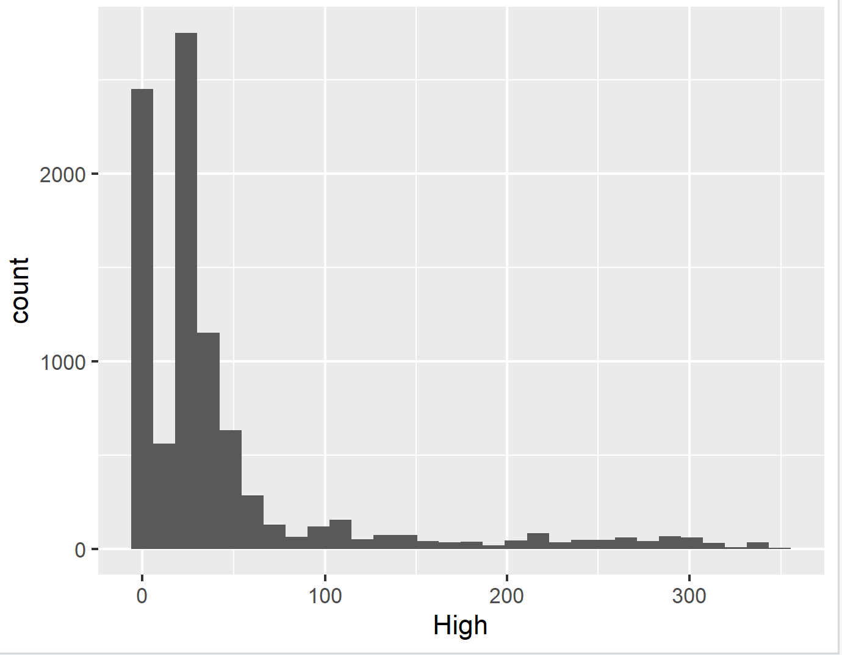

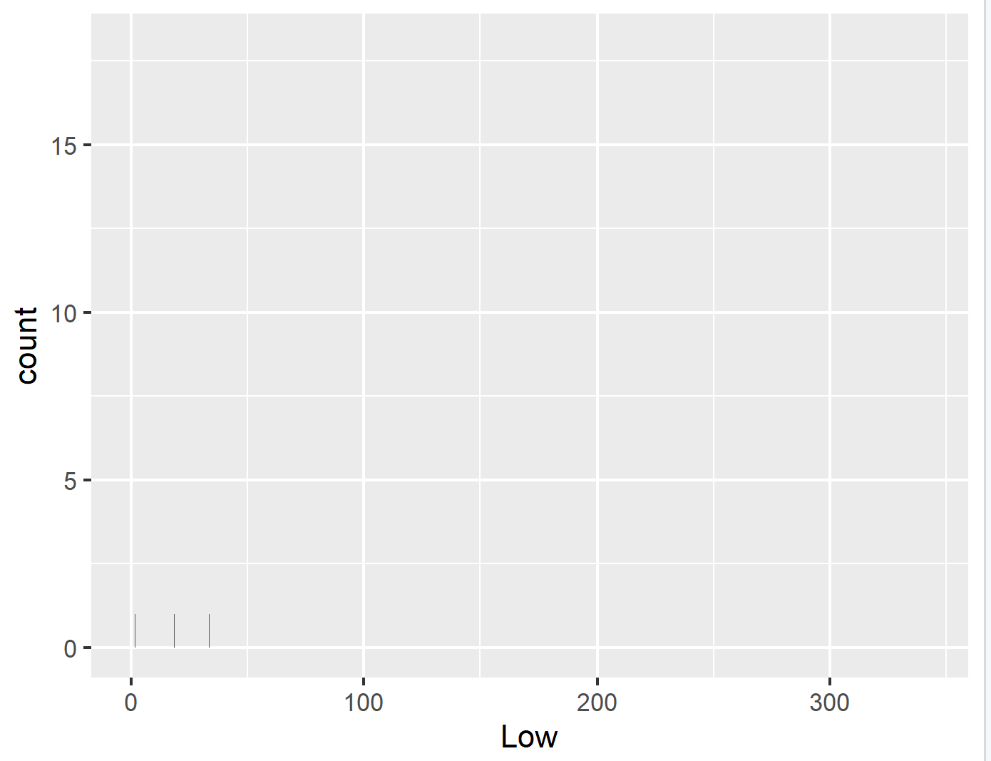

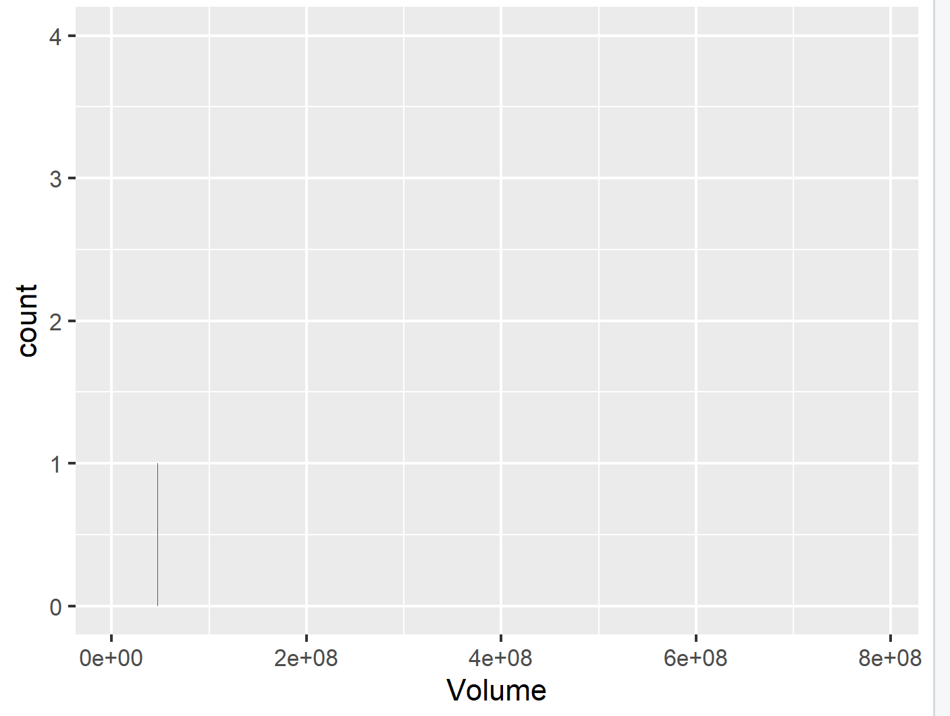

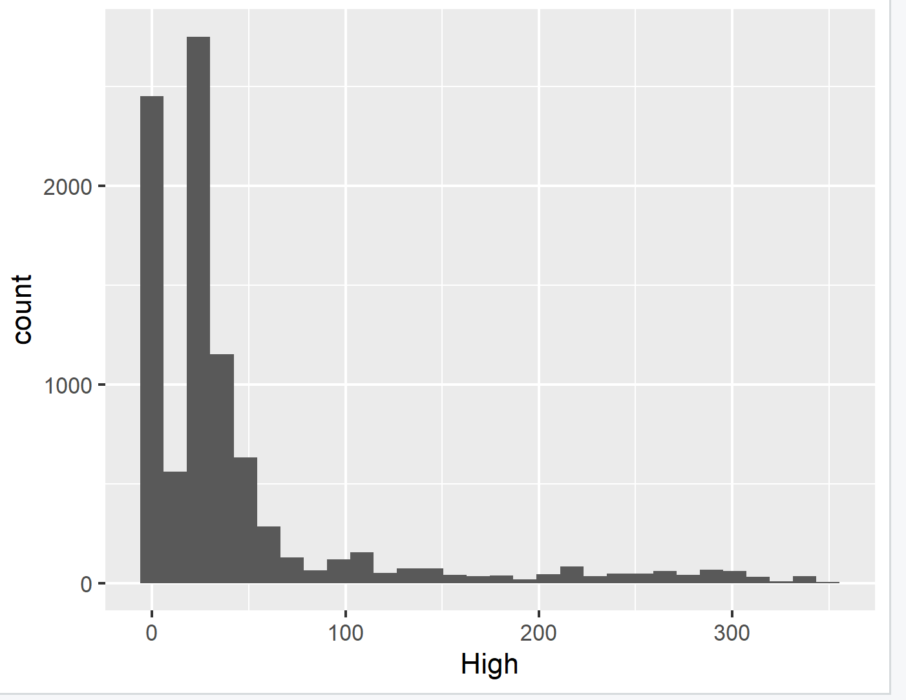

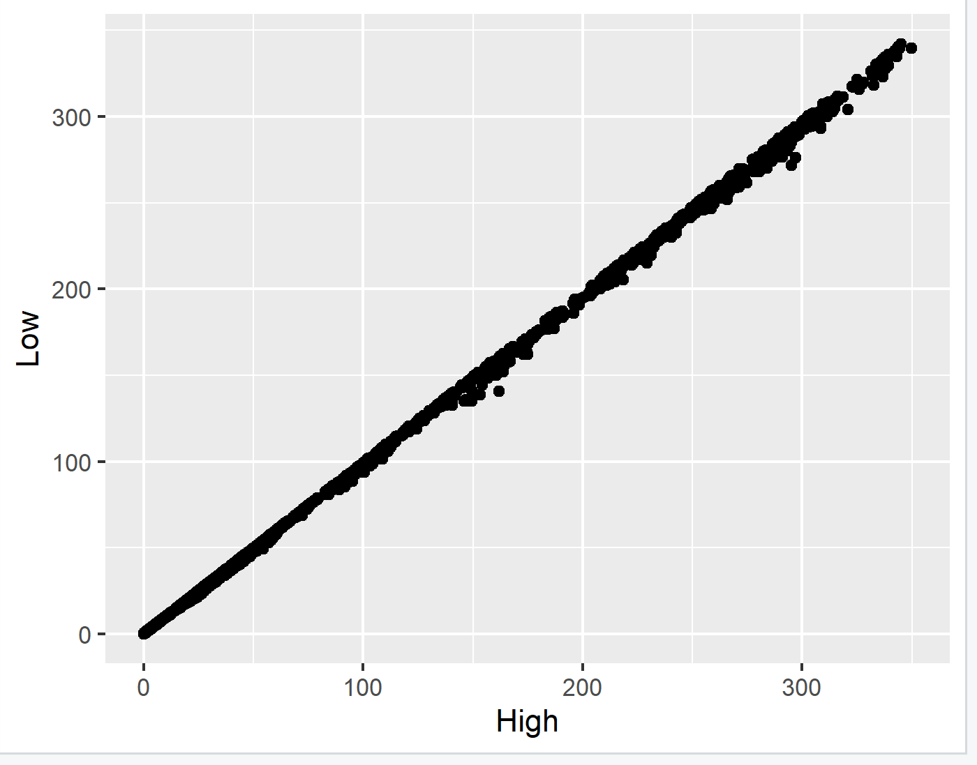

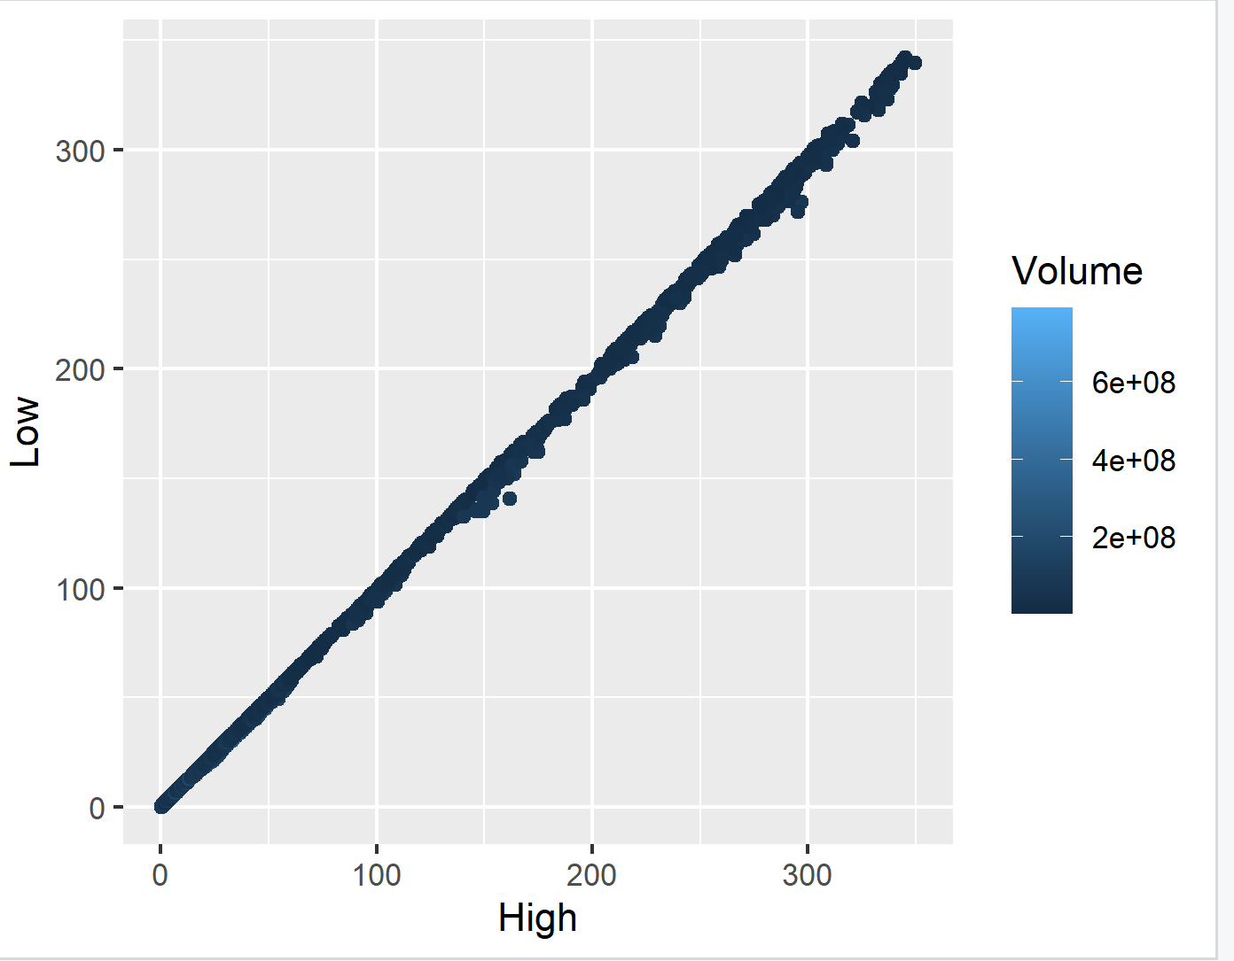

**Conclusions**

* Data Cleaning, Transforming ,Data visualization of the opening, Closing ,Volume , high ,low of the Microsoft has been found and Visualized.

**References**

[**https://www.kaggle.com/datasets/97ac1fbfabec74cdd827e3bba1c70a766e7442d89ee940ecb6cec1c6927ef81d?resource=download**](https://www.kaggle.com/datasets/97ac1fbfabec74cdd827e3bba1c70a766e7442d89ee940ecb6cec1c6927ef81d?resource=download)